COVID Drivers
Data Preparation and Modeling Report
Lisa Over
2026
Table of Contents
Introduction 4
Section 1: Data Preparation 5
1.1 Data Selection Rationale 5
Introduction 5
Variable Selection 5
Temporal Selection 7
Record Selection 7
Sampling Strategy 7
Connection to Data Science Goals from Business and Data Understanding 7
1.2 Data Cleaning Process 8
Missing Data Treatment 8
Outlier Detection and Handling 8
Inconsistency Resolution 9
Error Correction 10
Impact Assessment 10
1.3 Feature Engineering 10
Derived Features 10
Transformations 10
Temporal Features 11
Domain-specific Features 11
Feature Justification 11
1.4 Data Integration and Final Preparation 12
Integration Approach 12
Data Formatting 12
Train/Validation/Test Splitting 12
Final Dataset Characteristics 13
Preparation Pipeline 13
Section 2: Modeling 13
2.1 Modeling Strategy 13
Problem Framing 13
Algorithm Selection Rationale 13
Evaluation Strategy 14
Computational Considerations 14
Connection to Data Science Goals and Success Criteria 14
2.2 Model Development 14
Baseline Model 14
Primary Models 16
Computational Requirements 18
Model Interpretation 18
2.3 Model Evaluation and Comparison 18
Performance Metrics 18
Comparative Analysis 21
Diagnostic Evaluation 21
Robustness Testing 23
Organizational Metric Translation 23
2.4 Model Selection and Recommendations 24
Selected Model 24
Selection Justification 25
Limitations and Risks 25
Conclusion 25
Appendix A: Data Dictionary for Final Dataset 27
Appendix B: Coded CRASH Variable Fields 29
AI Statement of Use 30
Bibliography 30

Introduction
Studies show that Americans believe aggressive driving has increased since the COVID-19 pandemic, and super majorities believe that one or more of the following specific behaviors have increased: distracted driving, driving too fast, and reckless driving including weaving, tailgating, and running red lights. (Leppert, 2024, November 12). None of the evaluated studies showed a statistically significant increase in aggressive driving during COVID-19 or that aggressive driving declined or stabilized.
The objectives of this study are summarized below with the primary objective as number 1 and the secondary objectives as numbers 2-4. These objectives will be referenced numerically throughout this report.
Number | Objective | Summary
1 | Determine whether there has been a statistically significant increase in aggressive driving since the COVID-19 pandemic to provide evidence-based conclusions for PA Data Discourse readers about driving risks. | Based on several models, aggressive driving did not increase during COVID-19 and did not remain high afterward.
2 | Identify specific aggressive driving behaviors that increased during COVID-19. | The data indicate that no specific aggressive behavior (available in the public dataset) increased during COVID-19 or remained high afterward.
3 | Identify co-factors for crashes involving aggressive driving, such as age, day of week, geography, terrain, or atmospheric conditions. | Demographics such as age of the driver, urban or rural location of the crash, driver impairment, and status of the driver’s license were modeled along with the COVID-19 flag to determine if any of these factors covaried to predict aggressive driving behaviors. Resulting models indicated that none of these factors sufficiently predicted aggressive driving.
4 | Develop accessible visualizations for public understanding. | Times series plots were created to show the patterns in aggressive driving as defined as at least one aggressive behavior action, at least two aggressive behavior actions (NHTSA), and specific aggressive behaviors that are available in the public dataset.

Section 1: Data Preparation

Data Selection Rationale

Introduction
Data selection was influenced by personal communication with R. Ranieri (personal communication, February 19, 2026), Crash Analysis Manager for PennDOT, confirmed that variables in the FLAGS dataset are derived from all collection datasets—COMMVEH, CYCLE, PERSON, ROADWAY, TRAILVEH, VEHICLE—from the Pennsylvania Crash Information Tool (Pennsylvania Crash Information Tool, n.d.).
R. Ranieri (personal communication, February 19, 2026) confirmed that the behaviors in the following table are classified as aggressive driving, and he mapped each behavior to a FLAGS variable, if one exists. The public dataset does not contain a FLAGS variable for every aggressive driving behavior. PennDOT derived AGGRESSIVE_DRIVING and NHTSA_AGG_DRIVING from the aggressive driving behaviors listed below, including those not included in the public dataset.
Behavior | Corresponding FLAGS Variable
Making illegal u-turn
Improper/careless turning
Turning from wrong lane
Proceeding w/o clearance after stop | NO_CLEARANCE
Running stop sign | RUNNING_STOP_SIGN
Running red light
Failure to respond to other traffic control device | RUNNING_RED_LT
Tailgating | TAILGATING
Sudden slowing/stopping
Careless passing or lane change
Passing in no passing zone
Making improper entrance to highway
Making improper exit from highway
Speeding | SPEEDING, SPEEDING_RELATED†
Driving too fast for conditions | SPEEDING_RELATED†
Driver fleeing police | SPEEDING_RELATED†
† SPEEDING_RELATED encompasses all three of speeding, driving too fast for conditions, and driver fleeing police (R. Ranieri, personal communication, February 19, 2026)

Variable Selection
The features for this project were selected or derived to address the primary and secondary objectives. The variables, their source, and reason for selection are provided below.
Variable | Source | Reason
CRN | CRASH | Primary key for merging and record selection
CRASH_DATE | DERIVED | Timestamp derived from CRASH_MONTH and CRASH_YEAR
CRASH_MONTH | CRASH | To combine with CRASH_MONTH to create a timestamp for time series analysis
CRASH_YEAR | CRASH | To combine with CRASH_YEAR to create a timestamp for time series analysis
POST_COVID | DERIVED | Outcome variable as 1 if on or after March 1, 2020 and 0 if before March 30, 2020.
CRN | FLAGS | Primary and foreign key for merging
AGGRESSIVE_DRIVING | FLAGS | To determine if instances of any aggressive driving increased during COVID-19
CELL_PHONE | FLAGS | To determine if instances of cell phone use increased during COVID-19
DISTRACTED | FLAGS | To determine if instances of distracted driving increased during COVID-19
FATIGUE_ASLEEP | FLAGS | To determine if driver fatigue or being asleep is a co-factor with COVID-19 in predicting aggressive driving
HIT_RUN | FLAGS | To determine if driver hit and run is a co-factor with COVID-19 in predicting aggressive driving
IMPAIRED_DRIVER | FLAGS | To determine if driver impairment is a co-factor with COVID-19 in predicting aggressive driving
NHTSA_AGG_DRIVING | FLAGS | To determine if instances of aggressive driving as defined by NHTSA increased during COVID-19
MATURE_DRIVER | FLAGS | To determine if driver age is a co-factor with COVID-19 in predicting aggressive driving
NO_CLEARANCE | FLAGS | To determine if instances of drivers proceeding without clearance increased during COVID-19
RUNNING_RED_LT | FLAGS | To determine if instances of running red lights increased during COVID-19
RUNNING_STOP_SIGN | FLAGS | To determine if instances of running stop signs increased during COVID-19
SPEEDING | FLAGS | To determine if instances of speeding increased during COVID-19
SPEEDING_RELATED | FLAGS | To determine if instances of speeding, driving too fast for conditions, or driver fleeing police increased during COVID-19
TAILGATING | FLAGS | To determine if instances of tailgating decreased during COVID-19
UNLICENSED | FLAGS | To determine if driver being unlicensed is a co-factor with COVID-19 in predicting aggressive driving
URBAN_RURAL | FLAGS | To determine if crash urban or rural location is a co-factor with COVID-19 in predicting aggressive driving
YOUNG_DRIVER | FLAGS | To determine if driver age is a co-factor with COVID-19 in predicting aggressive driving
CRN | VEHICLE | Primary and foreign key for merging
UNIT_NUM | VEHICLE | Primary key and foreign key for merging
UNIT_TYPE | VEHICLE | To select only vehicles in transit or hit and run

Temporal Selection
All records from 2005 through 2024 will be used in the analysis. The established trends before COVID-19 are necessary for determining change points and altered trends during and after COVID-19.

Record Selection
Per R. Ranieri (personal communication, February 19, 2026), crashes that involved at least one motor vehicle in transit or that was a hit and run are the records of interest for analyzing aggressive driving behaviors. There has to be at least one driver of a vehicle in motion for there to be aggressive driving.

Sampling Strategy
The dataset was prepared for time series analysis to produce visualizations of the trends. This involved creating a datetime variable from the CRASH_MONTH and CRASH_YEAR where the day was consistently the first of the month. Then df.resample(‘MS’).mean() was used to summarize the dataset by taking the mean value over the months.
The dataset was prepared for Random Forest, Logistic Regression, and XGBoost machine learning algorithms by splitting the data into training and test sets. The random_state parameter was set to the same value for all training-test splits and all algorithms to ensure consistent and comparable results.

Connection to Data Science Goals from Business and Data Understanding
One impetus for this study was the Pew Research Study “Many Americans perceive a rise in dangerous driving; 78% see cellphone distraction as major problem” (Leppert, 2024, November 12). This study showed that Americans believe that both aggressive and distracted driving increased during COVID-19 and remain high. The choice of variables includes the aggressive driving behaviors in the public dataset and two other flags: CELL_PHONE and DISTRACTED. This choice was made to address public sentiments around aggressive driving and cell phone use or distracted driving.
Algorithms for this study were selected to predict if crashes before and after COVID could be classified into one of two classes: crashes that involved aggressive or distracted driving and those that did not. A change in behavior would be confirmed if more crashes during and after COVID-19 involve aggressive or distracted driving than before COVID-19, and public sentiment would also be confirmed.
Methods for detecting a change in behavior included a confusion matrix and measures of performance for classification, including accuracy, sensitivity, specificity, F-measure, and Area Under the Curve (AUC). The final model must perform with F-measure and AUC each greater than 0.7 to confirm a change in behavior.

Data Cleaning Process

Missing Data Treatment
There are no missing values in the selected row and columns of the CRASH, FLAGS, or VEHICLE datasets.

Outlier Detection and Handling
Outliers are visible in time series plots as shown in the examples below. The drops, spikes, and changes in trend are visual outliers that are important for this analysis; they may be the change points sought after in this project. Therefore, they will not be removed or modified in any way.
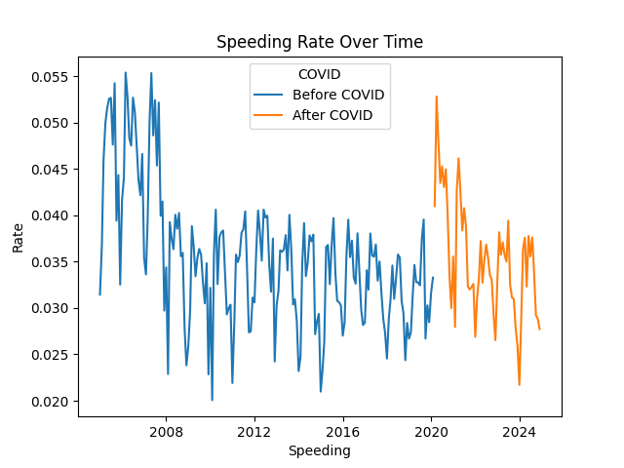 | There is a clear, large drop in speeding in 2008 with no apparent increase until a spike in 2020 during COVID-19.
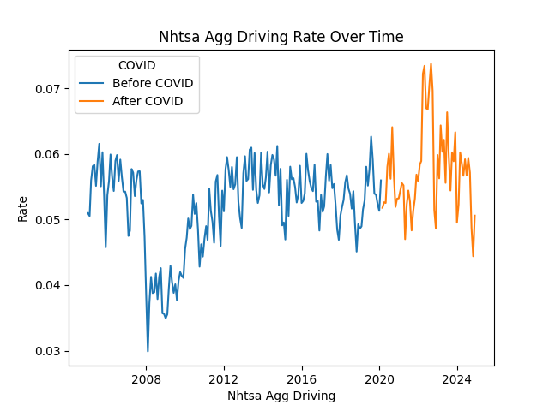 | There is a clear spike in aggressive driving as defined by NHTSA during COVID-19.
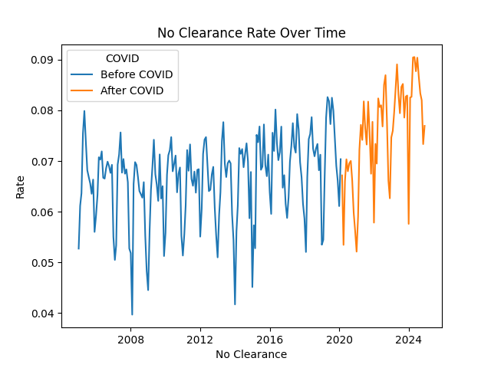 | There is a drop in crashes involving a vehicle proceeding without appropriate clearance during COVID-19 and a clear increase in the trend after COVID-19.

Inconsistency Resolution
R. Ranieri (personal communication, February 19, 2026) recommended using the collection tables to derive variable flags if inconsistencies exist between FLAGS variables and the related collection data. This may not be possible in every case because the public dataset does not include all variables that PennDOT used to create the FLAGS dataset.
Unique combinations of URBAN_RURAL, URBAN, and RURAL values in the table below show inconsistencies between the URBAN_RURAL variable in CRASH and the two FLAGS variables URBAN and RURAL.
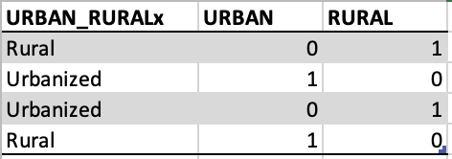
Therefore, the CRASH variable URBAN_RURAL was selected for the secondary objective to determine if urban/rural location is a co-factor with COVID-19 in predicting aggressive or distracted driving.
There were also inconsistencies between driver age counts in CRASH and the corresponding flag variable in FLAGS. Driver age counts in CRASH were derived from the PERSON table. The number of crashes where the driver age count was 0 and the corresponding flag was 1 appear in the table below.
An attempt was made to calculate the counts and derive the flags. R. Ranieri (personal communication, February 19, 2026) instructed to use crashes that involved a vehicle in transit or hit and run and to filter out bicycles as the VEHICLE dataset includes bicycles. Most calculated counts matched the counts in the CRASH dataset with only 138 still not matching. The difficulty in performing the same calculation as PennDOT made this activity untenable for the time available for this project. The FLAGS variables MATURE_DRIVER and YOUNG_DRIVER were used to determine if age was a co-factor with COVID-19 in predicting aggressive or distracted driving.
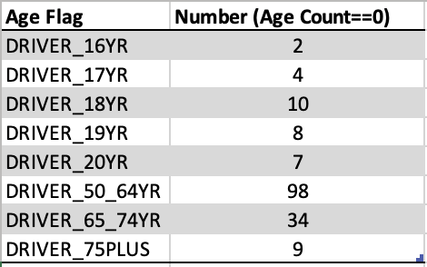

Error Correction
The fact that the public dataset does not include all variables used to derive FLAGS variables makes it impractical and unfeasible to determine if errors exist or to resolve errors if they are suspected. No corrections were made to the data for this project.

Impact Assessment
No cleaning was performed to correct the inconsistencies noted above. The evaluation informed the data selection process only.

Feature Engineering

Derived Features
POST_COVID was derived as a flag variable to indicate if a month was before COVID-19 or during or after. The lockdown for COVID-19 began in early March of 2020. The POST_COVID variable was set to 1 for crashes where CRASH_YEAR is greater than 2020 or where CRASH_YEAR is equal to 2020 and CRASH_MONTH is greater than or equal to 3 to indicate the crash occurred during or after COVID-19. Otherwise, POST_COVID was set to 0 to indicate the crash occurred before COVID-19.
CRASH_DATE was derived from CRASH_MONTH and CRASH_YEAR to create a timestamp for visualizing the data as a time series. This showed the trend and seasonality of variables with respect to COVID-19.

Transformations
Transformations to numerically encoded variables were derived to make evaluation more understandable and to use in visualization legends, axis names, and titles. Examples are shown below.
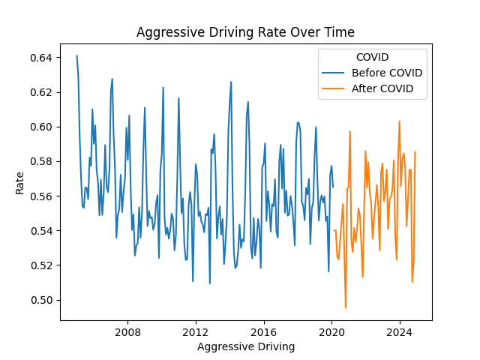 | POST_COVIDx is a text variable used in the legend of the time series plots.
 | URBAN_RURALx was used in the quality assessment of URBAN_RURAL, URBAN, and RURAL variables.
URBAN_RURAL was transformed into one-hot encoded variables in the preprocessing step of the modeling pipelines.
No variables were transformed to be normally distributed as normality in predictors and outcomes is not required in logistic regression or random forest classification.

Temporal Features
The POST_COVID flag was used in time series plots to clearly differentiate between pre- and post-COVID-19 crashes. This enabled a preliminary, visual review of changes in aggressive driving patterns during and after COVID-19, if they occurred.

Domain-specific Features
No domain-specific features were created.

Feature Justification
The POST_COVID flag was a critical predictor variable for the models to determine if aggressive or distracted driving could be predicted by COVID-19.
CRASH_DATE was necessary for creating time series visualizations, which revealed the trend and seasonality of the data before and after COVID-19. Below is an example of NO_CLEARANCE, which shows a drop in crashes involving a driver proceeding without clearance near the start of the lockdown when there were fewer cars to pull out in front of. It also shows a spike when more people began driving again. The violation then dropped and has started to be no more frequent than before COVID-19.
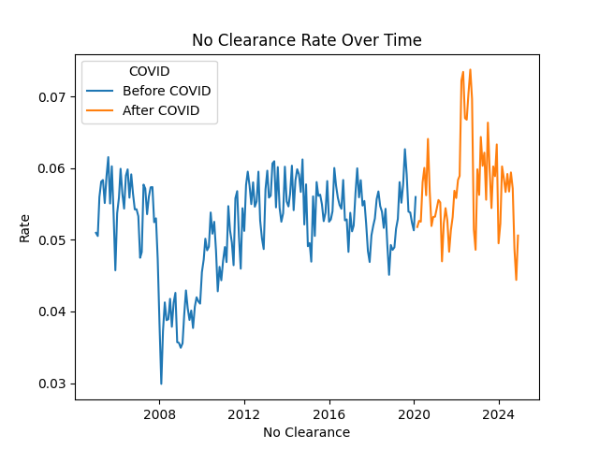
Even in the numerically encoded form, the URBAN_RURAL variable needed to be transformed to one-hot encoded variables for use in the models. This prevented the machine learning algorithms from assuming, incorrectly, that the categories had an ordinal or other type of relationship.

1.4 Data Integration and Final Preparation

Integration Approach
- Performed left join of CRASH and FLAGS datasets on ‘CRN.’ There is a one-to-one relationship between CRASH and FLAGS so no NULL values were created with this join. The granularity between both datasets is the same. Each record represents a crash.
- Filtered the VEHICLE dataset to include only vehicles with UNIT_TYPE in [1, 5], where 1 indicates ‘Motor vehicle in transport’ and 5 indicates ‘Hit and run vehicle.’
- Created a list of unique ‘CRN’ values from this resulting dataset.
- Selected records from the merged CRASH and FLAGS dataset where ‘CRN’ is in this unique list.
The resulting dataset included CRASH and FLAGS variables for crashes that involved at least one vehicle in motion.

Data Formatting
Structured data in wide format with one row per crash with all FLAGS variables as 1 or 0 (1=Yes and 0=No) and text variables transformed as one-hot encoded variables for logistic regression and random forest analysis. See Appendix A: Data Dictionary for Final Dataset.

Train/Validation/Test Splitting
Used 80/20 split with stratification on the target variable to ensure the splits are representative of the dataset. Random state was set consistently so results were comparable between algorithms focused on the same objective.
AGGRESSIVE_DRIVING and NHTSA_AGG_DRIVING were used as target variables, separately. The class balance with NHTSA_AGG_DRIVING required the class weight property to be set to ‘balance’ or ‘balanced_subsample’ to ensure the loss function paid attention to the minority class during training.

Final Dataset Characteristics
Final dataset contains 2,460,484 crash records with 15 features (12 numeric, 1 datetime, 1 categorical, 1 numeric key) with a 56/44 class split in the target variable AGGRESSIVE_DRIVING and a 5/95 class split in the target variable NHTSA_AGG_DRIVING.

Preparation Pipeline
Pipeline follows this sequence:
Step | Notebook(s)
Raw data import | covid_drivers_05_PREP
Feature engineering | covid_drivers_05_PREP
Merge datasets | covid_drivers_05_PREP
Filter records | covid_drivers_05_PREP
Decode variables | covid_drivers_05_PREP
Select columns | covid_drivers_05_PREP
Train/test split | covid_drivers_06_  covid_drivers_07_  covid_drivers_08_  covid_drivers_09_
One-hot encoding | covid_drivers_09_
All steps are documented in the above notebooks for reproducible analysis.

Section 2: Modeling

2.1 Modeling Strategy

Problem Framing
Framed as a binary classification problem to predict aggressive driving because this directly addresses the business goal of identifying if aggressive driving increased during COVID-19 and remained high.

Algorithm Selection Rationale
Selected logistic regression because the results are easy to interpret; random forest because it is a nonparametric algorithm that handles both linear and non-linear relationships, is resistant to noise and outliers, and provides estimates of feature relevance (Geeks for Geeks, 2025a); and gradient boosting because it handles imbalanced data well and provides maximum predictive performance. These three algorithms provide both simple and complex modeling for thorough analysis and comparison.
One-class classification was also chosen because it handles imbalanced data well. One class classification is an unsupervised learning algorithm that learns of the majority class and then classifies each record in the minority class as either an inlier or outlier. This algorithm was selected to model outcome variables when the minority class comprised less than 15% of the data. (Brownlee, 2019; Brownlee, 2020)

Evaluation Strategy
Evaluation involved an 80/20 train/test split with the F1 score and ROC AUC as the primary metrics. The F1 score is a measure of both precision* and recall** with a high score indicating a balance between the two. In this problem domain, it is important to balance precision and recall, because many false positives or false negatives indicates a failure to identify a clear change in behavior.
The ROC AUC is the area under the curve of the plot of the true positive rate verses the false positive rate, and it reflects the ability of the model to distinguish between the classes. This measure is important to consider in addition to the F1 score, because the primary model results were F1 score=0.7, precision=0.56, recall=1, and ROC AUC=0.5. A high recall, in this case a perfect recall, means the model is optimized to identify as many actual positives as possible so it incorrectly labels negatives as positives, leading to a high number of false positives. If the false positive rate is high, the ROC AUC will be lower, and an ROC AUC 0.5 is no better than random guessing. (Geeks for Geeks, 2026)
Both F1 score and ROC AUC are expected to be at least 0.7 to meet the business goal of predicting aggressive driving.
* Precision is a measure of how accurate the model is in predicting positive results; a higher precision means fewer false positives. A false positive in this domain means that crashes not involving aggressive driving behaviors are classified as such. (Geeks for Geeks, 2025b)
** Recall (true positive rate or sensitivity) is a measure of the ability of the model to find all positive instances; a higher recall means fewer false negatives. A false negative in this domain means that crashes involving aggressive driving are classified as not. (Geeks for Geeks, 2025b)

Computational Considerations
Working with a large dataset with almost 2.5M records. The number of features were kept to less than 10 because the dataset includes variables that combine many factors into one, e.g., YOUNG_DRIVER combines drivers aged 16-20. Standard models without grid search were initially run on a standard laptop. When using grid search and cross validation, Google Colaboratory was used with a reduced number of fits by running the models multiple times with fewer parameter options on each run.

Connection to Data Science Goals and Success Criteria
Model evaluation prioritizes F1 score and ROC AUC. A balance between accurately classifying positive cases (precision) and finding all positive cases (recall) as measured by the F1 score is not sufficient to identify aggressive driving. High recall at the expense of precision means that the model is labeling too many non-aggressive driving crashes as instances of aggressive driving. Misleading the public with a false narrative would not solve any problems. Requiring the model to be good at distinguishing between the classes (ROC AUC) is necessary to identify and report that COVID-19 resulted in a clear increase in aggressive or distracted driving behavior.

2.2 Model Development

Baseline Model
For baseline, the following models were developed with default hyperparameters.
Objective/Model | Algorithm | Notebook(s)
Objective 1:  POST_COVID ~ AGGRESSIVE_DRIVING | Logistic regression, random forest, gradient boosting | covid_drivers_06_PRIM_MODL_LGR  covid_drivers_06_PRIM_MODL_RF  covid_drivers_06_PRIM_MODL_XGB
Objective 1:  POST_COVID ~ NHTSA_AGG_DRIVING | Logistic regression, random forest, gradient boosting | covid_drivers_07_PRIM_MODL_LGR  covid_drivers_07_PRIM_MODL_RF  covid_drivers_07_PRIM_MODL_XGB
Objective 2:  POST_COVID ~ NO_CLEARNACE  POST_COVID ~ CELL_PHONE  POST_COVID ~ DISTRACTED  POST_COVID ~ RUNNING_RED_LT  POST_COVID ~ RUNNING_STOP_SIGN  POST_COVID ~ SPEEDING  POST_COVID ~ SPEEDING_RELATED  POST_COVID ~ TAILGATING | Support vector machine (one class classification) | covid_drivers_08_SEC_MODL_SVM
Objective 3:  POST_COVID, CELL_PHONE,  IMPAIRED_DRIVER, MATURE_DRIVER, YOUNG_DRIVER, FATIGUE_ASLEEP, HIT_RUN, UNLICENSED, URBAN_RURALx ~  AGGRESSIVE_DRIVING | Logistic regression, random forest, gradient boosting | covid_drivers_09_SEC_MODL_COFAC_AGGDRV
Objective 3:  POST_COVID, CELL_PHONE,  IMPAIRED_DRIVER, MATURE_DRIVER, YOUNG_DRIVER, FATIGUE_ASLEEP, HIT_RUN, UNLICENSED, URBAN_RURALx ~  NHTSA_AGG_DRIVING | Logistic regression, random forest, gradient boosting | covid_drivers_09_SEC_MODL_COFAC_NHTSA

Primary Models

Algorithm description and parameters
Objective/Model | Description and Parameters
Objective 1:  POST_COVID ~ AGGRESSIVE_DRIVING | Logistic regression with stratified, shuffled, 5-fold cross validation and best hyperparameters selected from GridSearchCV: C=0.01 and l1_ratio=0
Objective 2:  POST_COVID ~ NO_CLEARNACE  POST_COVID ~ CELL_PHONE  POST_COVID ~ DISTRACTED  POST_COVID ~ RUNNING_RED_LT  POST_COVID ~ RUNNING_STOP_SIGN  POST_COVID ~ SPEEDING  POST_COVID ~ SPEEDING_RELATED  POST_COVID ~ TAILGATING | Support vector machine for one class classification with temporal data selection to equalize pre- and post-data records. The hyperparameter nu=0.01 was selected incorrectly as the approximate ratio of outliers in the data (brownlee, 2020). This model runs for a very long time and was not re-run with correct approximation.
Objective 3:  POST_COVID, CELL_PHONE,  IMPAIRED_DRIVER, MATURE_DRIVER, YOUNG_DRIVER, FATIGUE_ASLEEP, HIT_RUN, UNLICENSED, URBAN_RURALx ~  AGGRESSIVE_DRIVING | Logistic regression with stratified, shuffled, 5-fold cross validation and best hyperparameters selected from GridSearchCV: C=0.01 and l1_ratio=0

Training process and challenges
Linear regression, random forest, and gradient boosting overfit the data with moderate to high accuracy, low precision, and high recall. Linear regression was selected for interpretability, not for its performance. Preprocessing of data for objective 3 required one-hot encoding for URBAN_RURALx.

Hyperparameter tuning approach
Fine tuning was performed using grid search to select the best combination of hyperparameter values from lists of plausible values for each. Grid search took a significant amount of time. When the number of fits required more than an hour to run, the number of hyperparameters was reduced to reduce the number of fits. In some instances, these smaller lists of values were adjusted to include the best value from a previous run and new values not tried, and the model re-run to see if the best value changed.

Training performance metrics
Objective/Model | Accuracy | Precision | Recall | F1 Score | ROC AUC
Objective 1:  POST_COVID ~ AGGRESSIVE_DRIVING | 0.5598 | 0.5598 | 1 | 0.7178 | 0.5030
Objective 2:  POST_COVID ~ NO_CLEARNACE |  |  |  | 0.1280
Objective 2:  POST_COVID ~ CELL_PHONE |  |  |  | 0.0000
Objective 2:  POST_COVID ~ DISTRACTED |  |  |  | 0.0000
Objective 2:  POST_COVID ~ RUNNING_RED_LT |  |  |  | 0.0000
Objective 2:  POST_COVID ~ RUNNING_STOP_SIGN |  |  |  | 0.0000
Objective 2:  POST_COVID ~ SPEEDING |  |  |  | 0.0000
Objective 2:  POST_COVID ~ SPEEDING_RELATED |  |  |  | 0.4020
Objective 2:  POST_COVID ~ TAILGATING |  |  |  | 0.0890
Objective 3:  POST_COVID, CELL_PHONE, IMPAIRED_DRIVER, MATURE_DRIVER, YOUNG_DRIVER, FATIGUE_ASLEEP, HIT_RUN, UNLICENSED, URBAN_RURALx ~  AGGRESSIVE_DRIVING | 0.5598 | 0.5598 | 1 | 0.7178 | 0.5193

Computational Requirements
Models with default parameters ran in a couple of minutes. Models involving grid search and the outcome variable AGGRESSIVE_DRIVING ran within an hour. Models involving grid search and the imbalanced outcome variable NHTSA_AGG_DRIVING ran for several hours and had to be stopped. All models took similar amounts of time whether running on a standard laptop with 8GB RAM and on Google Colaboratory with 12.67GB RAM. The support vector machine ran for several hours, but was not interrupted. However, the F1 score was the only measure collected and re-running to obtain additional metrics was impractical.
Too much time was spent on models with NHTSA_AGG_DRIVING since grid search ran too long. These models should have been abandoned early on in the process.

Model Interpretation
Each model consistently told the same story, that is, there is no evidence that aggressive driving increase during COVID-19 and remained high after.

2.3 Model Evaluation and Comparison

Performance Metrics

Logistic Regression (C=0.01, l1_ratio=0)
Objective/Model | Accuracy | Precision | Recall | F1 Score | ROC AUC
Objective 1:  POST_COVID ~ AGGRESSIVE_DRIVING | 0.5598 | 0.5598 | 1 | 0.7178 | 0.5030
Objective 3:  POST_COVID, CELL_PHONE, IMPAIRED_DRIVER, MATURE_DRIVER, YOUNG_DRIVER, FATIGUE_ASLEEP, HIT_RUN, UNLICENSED, URBAN_RURALx ~  AGGRESSIVE_DRIVING | 0.5598 | 0.5598 | 1 | 0.7178 | 0.5193

Random Forest (n_estimators=50, max_depth=None)
Objective/Model | Accuracy | Precision | Recall | F1 Score | ROC AUC
Objective 1:  POST_COVID ~ AGGRESSIVE_DRIVING | 0.5598 | 0.5598 | 1 | 0.7178 | 0.5030
Objective 3:  POST_COVID, CELL_PHONE, IMPAIRED_DRIVER, MATURE_DRIVER, YOUNG_DRIVER, FATIGUE_ASLEEP, HIT_RUN, UNLICENSED, URBAN_RURALx ~  AGGRESSIVE_DRIVING | 0.5598 | 0.5598 | 1 | 0.7178 | 0.5193

XGBoost (default)
Objective/Model | Accuracy | Precision | Recall | F1 Score | ROC AUC
Objective 1:  POST_COVID ~ AGGRESSIVE_DRIVING | 0.5597 | 0.5597 | 1 | 0.7177 | 0.5039
Objective 3:  POST_COVID, CELL_PHONE, IMPAIRED_DRIVER, MATURE_DRIVER, YOUNG_DRIVER, FATIGUE_ASLEEP, HIT_RUN, UNLICENSED, URBAN_RURALx ~  AGGRESSIVE_DRIVING | 0.5598 | 0.5598 | 1 | 0.7178 | 0.5193

Support Vector Machine (nu=0.01)

Objective/Model | Accuracy | Precision | Recall | F1 Score | ROC AUC
Objective 2:  POST_COVID ~ NO_CLEARNACE |  |  |  | 0.1280
Objective 2:  POST_COVID ~ CELL_PHONE |  |  |  | 0.0000
Objective 2:  POST_COVID ~ DISTRACTED |  |  |  | 0.0000
Objective 2:  POST_COVID ~ RUNNING_RED_LT |  |  |  | 0.0000
Objective 2:  POST_COVID ~ RUNNING_STOP_SIGN |  |  |  | 0.0000
Objective 2:  POST_COVID ~ SPEEDING |  |  |  | 0.0000
Objective 2:  POST_COVID ~ SPEEDING_RELATED |  |  |  | 0.4020
Objective 2:  POST_COVID ~ TAILGATING |  |  |  | 0.0890

Comparative Analysis
Logistic regression provides coefficients for independent variables that are easily interpretable to a wide audience. Random forest is not as easily interpreted for the public; however, it is a good option for comparison because it is a nonparametric algorithm that handles both linear and non-linear relationships and is resistant to noise and outliers (Geeks for Geeks, 2025a). Gradient boosting handles imbalanced data well and provides maximum predictive performance.

Diagnostic Evaluation
Confusion matrices were not obtained for support vector machine models. The confusion matrices below, along with the low ROC AUC values, suggest that all models are overfitting the data. The random_state value is set to 42 for the logistic regression, random forest, and gradient boosting algorithms for consistent results and comparability. The support vector machine random_state setting is set to 2 for all runs. This was an oversite, but the models run by this algorithm are different from the models run by logistic regression, random forest, and gradient boosting and would not be compared to them anyway.

Logistic Regression (C=0.01, l1_ratio=0)
Objective/Model
Objective 1:  POST_COVID ~ AGGRESSIVE_DRIVING | 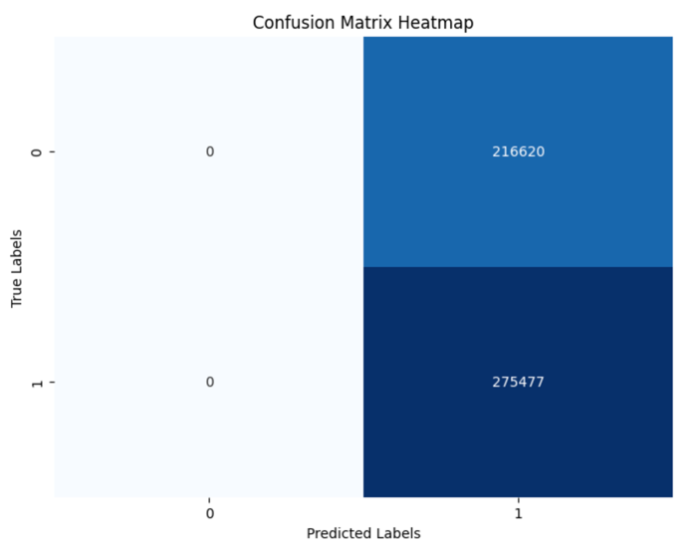
Objective 3:  POST_COVID, CELL_PHONE, IMPAIRED_DRIVER, MATURE_DRIVER, YOUNG_DRIVER, FATIGUE_ASLEEP, HIT_RUN, UNLICENSED, URBAN_RURALx ~  AGGRESSIVE_DRIVING | 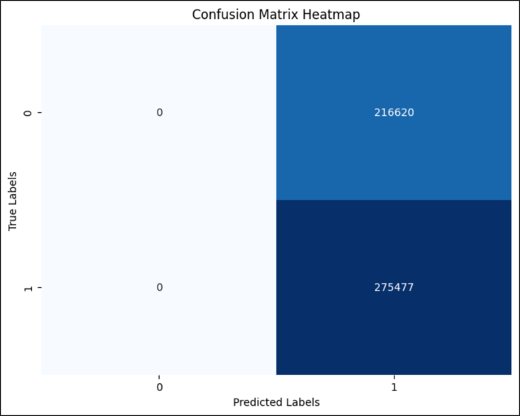

Random Forest (n_estimators=50, max_depth=None)
Objective/Model
Objective 1:  POST_COVID ~ AGGRESSIVE_DRIVING | 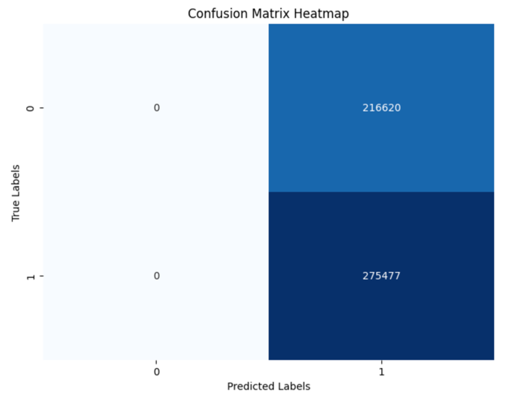
Objective 3:  POST_COVID, CELL_PHONE, IMPAIRED_DRIVER, MATURE_DRIVER, YOUNG_DRIVER, FATIGUE_ASLEEP, HIT_RUN, UNLICENSED, URBAN_RURALx ~  AGGRESSIVE_DRIVING | 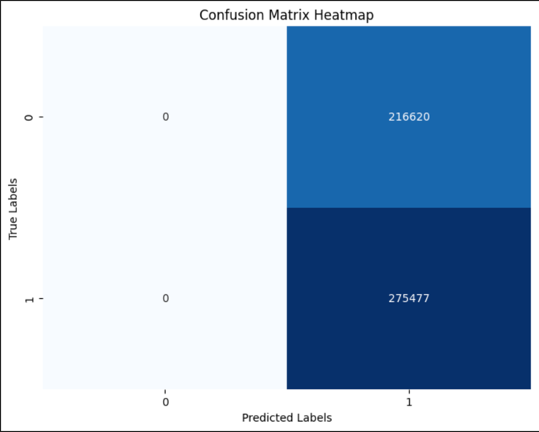

XGBoost (default)
Objective/Model
Objective 1:  POST_COVID ~ AGGRESSIVE_DRIVING | 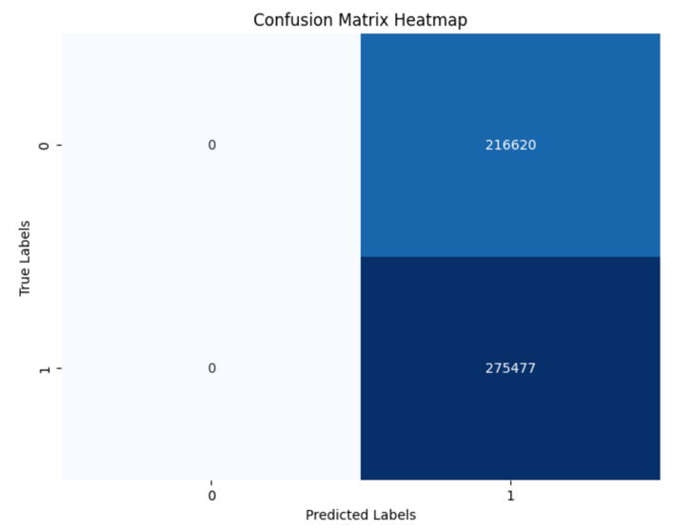
Objective 3:  POST_COVID, CELL_PHONE, IMPAIRED_DRIVER, MATURE_DRIVER, YOUNG_DRIVER, FATIGUE_ASLEEP, HIT_RUN, UNLICENSED, URBAN_RURALx ~  AGGRESSIVE_DRIVING | 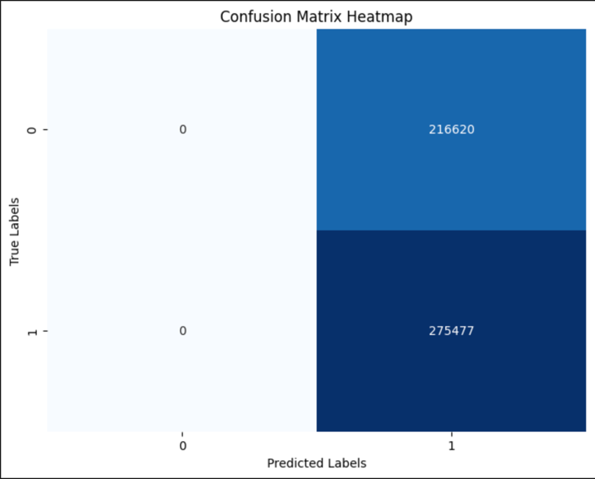

Robustness Testing
Demographics such as age of the driver, urban or rural location of the crash, driver impairment, and status of the driver’s license were modeled along with POST_COVID to determine if any of these factors covaried with aggressive driving behaviors. The data were not split up for this analysis. All models were run on the complete dataset.

Organizational Metric Translation
Objective/Model | Metric Translation
Objective 1:  POST_COVID ~ AGGRESSIVE_DRIVING | Although the F1 scores for the models met the success criteria at 0.718, the ROC AUC values were low at 0.5. This means the model is not good at distinguishing between the classes. There is no evidence that aggressive driving increased during COVID-19 and remained high after.
Objective 2:  POST_COVID ~ NO_CLEARNACE  POST_COVID ~ CELL_PHONE  POST_COVID ~ DISTRACTED  POST_COVID ~ RUNNING_RED_LT  POST_COVID ~ RUNNING_STOP_SIGN  POST_COVID ~ SPEEDING  POST_COVID ~ SPEEDING_RELATED  POST_COVID ~ TAILGATING | The F1 score is the only metric collected from these models. No scores met the success criteria of 0.7. There is no evidence that any specific aggressive driving behavior increased during COVID-19 and remained high.
Objective 3:  POST_COVID, CELL_PHONE,  IMPAIRED_DRIVER, MATURE_DRIVER, YOUNG_DRIVER, FATIGUE_ASLEEP, HIT_RUN, UNLICENSED, URBAN_RURALx ~  AGGRESSIVE_DRIVING | Although the F1 scores for the models met the success criteria at 0.718, the ROC AUC values were low at 0.52. This means the model is not good at distinguishing between the classes. There is no evidence that aggressive driving increased during COVID-19 and remained high or that co-factors, such as age of the driver, urban or rural location of the crash, driver impairment, and status of the driver’s license contributed to an increase.

2.4 Model Selection and Recommendations

Selected Model
None of the models indicate a statistically significant increase in aggressive or distracted driving behavior during and after COVID-19. All models produced similar results. The time series plots indicate some change—either a drop or spike—in aggressive and distracted driving, specifically with speeding, cell phone use, no clearance, and tailgating as shown below. A different algorithm or approach may detect these changes.

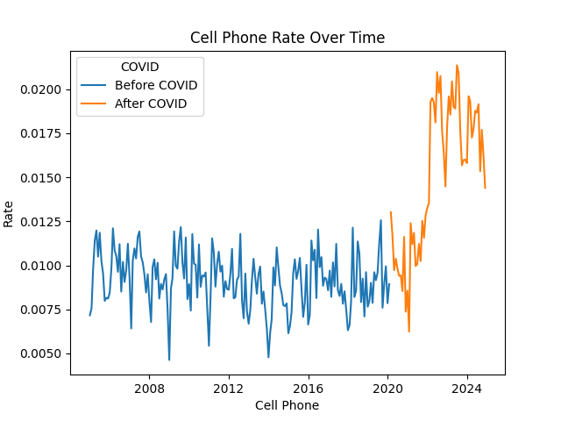
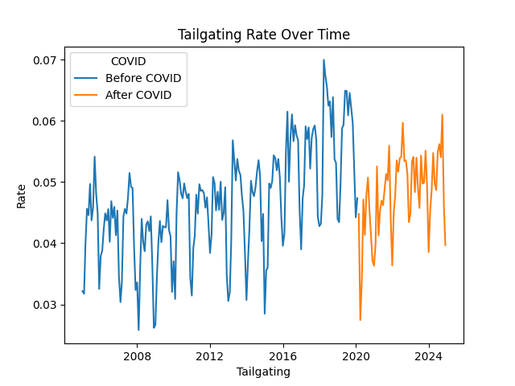

Selection Justification
No model was selected for its ability to differentiate the aggressive driving classes. The logistic regression models for objectives 1 and 3 were selected because the stakeholders are more likely to be familiar with this approach. The support vector machine models for objective 2 were selected because they were the only models run for objective 3. All selected models were chosen to show that there is no evidence that aggressive or distracted driving increased during COVID-19 and remained high.

Limitations and Risks
Model performance may accurately reflect reality; however, the computational drain when running multiple models with grid search was a significant limitation. Models ran for several hours even when grid search involved only 40 fits. This may be because of the nature of the data, which suggests these algorithms may not be the best choice for this data and problem scenario.

Conclusion
The selected dataset consisting of 2,460,484 crash records with 15 features (12 numeric, 1 datetime, 1 categorical, 1 numeric key) and with a 56/44 class split in the target variable AGGRESSIVE_DRIVING and a 5/95 class split in the target variable NHTSA_AGG_DRIVING.
Results from modeling PennDOT crash data do not support the public sentiment that aggressive or distracted driving increased during COVID-19 and remained high. Results also do not support a change in any specific aggressive or distracted driving behaviors, modeled individually. Finally, results do not support a relationship between COVID-19; aggressive or distracted driving; and demographic characteristics such as age of the driver, urban or rural location of the crash, driver impairment, and status of the driver’s license. However, some visualizations indicate clear drops and spikes in specific driving behaviors of interest to the public.
It is recommended that ARIMA modeling be conducted on pre-COVID data to determine if the predicted time series diverge from the post-COVID data. This could be done for AGGRESSIVE_DRIVING, NHTSA_AGG_DRIVING, and individual aggressive and distracted driving behaviors. Additional data may also provide information that supports public sentiment. Traffic citations are public and could be obtained from court records.
The imbalanced nature of NHTSA_AGG_DRIVING and specific driving behaviors make modeling these outcomes difficult. Not all aggressive driving actions result in a crash, so the public sentiment could still be accurate even if the crash data do not support it. If the recommended time series analysis still indicates no statistically significant change in behavior, it is important to inform the public in a way that does not dismiss their personal experience.

Appendix A: Data Dictionary for Final Dataset
Column | Description (PENNDOT, 2025) | Data Type | Number of Unique | Missing | Range/Unique
AGGRESSIVE_DRIVING | At least one aggressive driver action by a driver | int64 | 2 | 0 (0.0%) | [0, 1]
CELL_PHONE | At least one driver using cell phone, either hand-held or hands-free | int64 | 2 | 0 (0.0%) | [0, 1]
CRASH_DATE | Timestamp derived from CRASH_MONTH and CRASH_YEAR | int64 | 240 | 0 (0.0%) | [1, 12]
CRN (PK) | Crash record number - unique identifier | int64 | 2461193 | 0 (0.0%) | [2005000003, 2025050430]
DISTRACTED | At least one action indicating driver distraction | Int64 | 2 | 0 (0.0%) | [0, 1]
NHTSA_AGG_DRIVING | The crash meets the definition for aggressive driving established by NHTSA; this is defined in the PennDOT Open Data Portal Crash Data Dictionary and Field Constraints Tables (PennDOT, 2025) as a driver engaging in at least two aggressive driving behaviors | int64 | 2 | 0 (0.0%) | [0, 1]
NO_CLEARANCE | At least one vehicle proceeded without  clearance after a stop | int64 | 2 | 0 (0.0%) | [0, 1]
POST_COVID | Indicates if crash occurred before COVID-19 (0) or during or after COVID-19 (1) | int64 | 2 | 0 (0.0%) | [0, 1]
RUNNING_RED_LT | At least one driver ran a red light | int64 | 2 | 0 (0.0%) | [0, 1]
RUNNING_STOP_SIGN | At least one driver ran a stop sign | int64 | 2 | 0 (0.0%) | [0, 1]
SPEEDING | At least one driver was speeding | int64 | 2 | 0 (0.0%) | [0, 1]
SPEEDING_RELATED | At least one driver was speeding, driving too fast for conditions, or fleeing police (R. Ranieri, personal communication, February 19, 2026) | int64 | 2 | 0 (0.0%) | [0, 1]
TAILGATING | At least one driver was tailgating or following too closely | int64 | 2 | 0 (0.0%) | [0, 1]
URBAN_RURAL † | Code that identifies the location of the crash as either urban or rural | int64 | 2 | 0 (0.0%) | [1, 2]
URBAN_RURALx † | Decoded values that identify the location of the crash as either urban or rural | string | 2 | 0 (0.0%) | [Rural, Urbanized]

† See Appendix B: Coded CRASH Variable Fields for the definitions of enumerated values for each field.

Appendix B: Coded CRASH Variable Fields
unit_type  1: 'Motor vehicle in transport'  2: 'Legally parked'  3: 'Illegally parked'  5: 'Hit and run vehicle'  6: 'Disabled from a previous crash'  21: 'Train'  30: 'Non-Motorist'  33: 'Personal Delivery Device'  51: 'Phantom vehicle' | urban_rural  1: 'Rural'  2: 'Urbanized'  3: 'Urban'

AI Statement of Use
AI (Chatbot App—AI Chatbot) was used to troubleshoot errors, especially errors related to setting up the virtual environment. It was also used to look up code syntax and definitions of terms for better understanding. AI was not used for writing or coding. No blocks of text or code were copied from AI for use in this project.

Bibliography
Brownlee, J. (2019, December 22). A Gentle Introduction to Imbalanced Classification. MachineLearningMastery.Com. https://www.machinelearningmastery.com/what-is-imbalanced-classification/
Brownlee, J. (2020, February 13). One-Class Classification Algorithms for Imbalanced Datasets. MachineLearningMastery.Com. https://www.machinelearningmastery.com/one-class-classification-algorithms/
Chatbot App—AI Chatbot. (n.d.). Retrieved February 1, 2026, from https://chat.chatbot.app/?model=gpt-5-mini
Geeks for Geeks. (2025a, July 23). What are the Advantages and Disadvantages of Random Forest? GeeksforGeeks. https://www.geeksforgeeks.org/machine-learning/what-are-the-advantages-and-disadvantages-of-random-forest/
Geeks for Geeks. (2025b, August 2). Precision and Recall in Machine Learning. GeeksforGeeks. https://www.geeksforgeeks.org/machine-learning/precision-and-recall-in-machine-learning/
Geeks for Geeks. (2026, March 12). AUC ROC Curve in Machine Learning. GeeksforGeeks. https://www.geeksforgeeks.org/machine-learning/auc-roc-curve/
J, G. (2022, July 31). Using Class Weight to Compensate for Imbalanced Data. Medium. https://medium.com/@bubbapora_76246/using-class-weight-to-compensate-for-imbalanced-data-6eff370185d3
Leppert, A. J. and R. (2024, November 12). Many Americans perceive a rise in dangerous driving; 78% see cellphone distraction as major problem. Pew Research Center. https://www.pewresearch.org/short-reads/2024/11/12/many-americans-perceive-a-rise-in-dangerous-driving-78-see-cellphone-distraction-as-major-problem/
PennDOT. (2025). Data Dictionary and Field Constraints Tables. https://gis.penndot.pa.gov/gishub/crashZip/Crash_Data_Dictionary_2025.pdf
PennDOT. (n.d.). Distracted Driving. Retrieved January 22, 2026, from https://www.pa.gov/agencies/penndot/traveling-in-pa/safety/traffic-safety-driver-topics/distracted-driving
PennDOT Crash Data Download. (n.d.). Pennsylvania Department of Transportation. Retrieved January 25, 2026, from https://experience.arcgis.com/experience/51809b06e7b140208a4ed6fbad964990
Pennsylvania Crash Information Tool. (n.d.). Retrieved January 25, 2026, from https://crashinfo.penndot.pa.gov/PCIT/welcome.html?TYPE=33554433&REALMOID=06-6e7f3fd5-ee48-4b22-8067-774762688650&GUID=&SMAUTHREASON=0&METHOD=GET&SMAGENTNAME=-SM-E%2bZZmVPChvgeLWKfG1BgkUwXVkEogJGcRA5yj1Pa9OazD3%2fSbooshnw8PzBLhpiK&TARGET=-SM-https%3a%2f%2fcrashinfo%2epenndot%2epa%2egov%2f#

